**CS 211  
LAB 3: Exceptions in MIPS**

**Name – Gautam Kumar Mahar  
Roll No. – 2103114  
Branch – Computer Science Engineering**

**PART B**

**In this part, you will write MIPS assembly language programs to do the following exercises.**

1. **Reverse a string entered by a user. (Hint: Ask the user to enter a string. After reading the string in a buffer, copy it in reversed order to a second buffer. Write out the reversed string.)**

**In Decimal –**

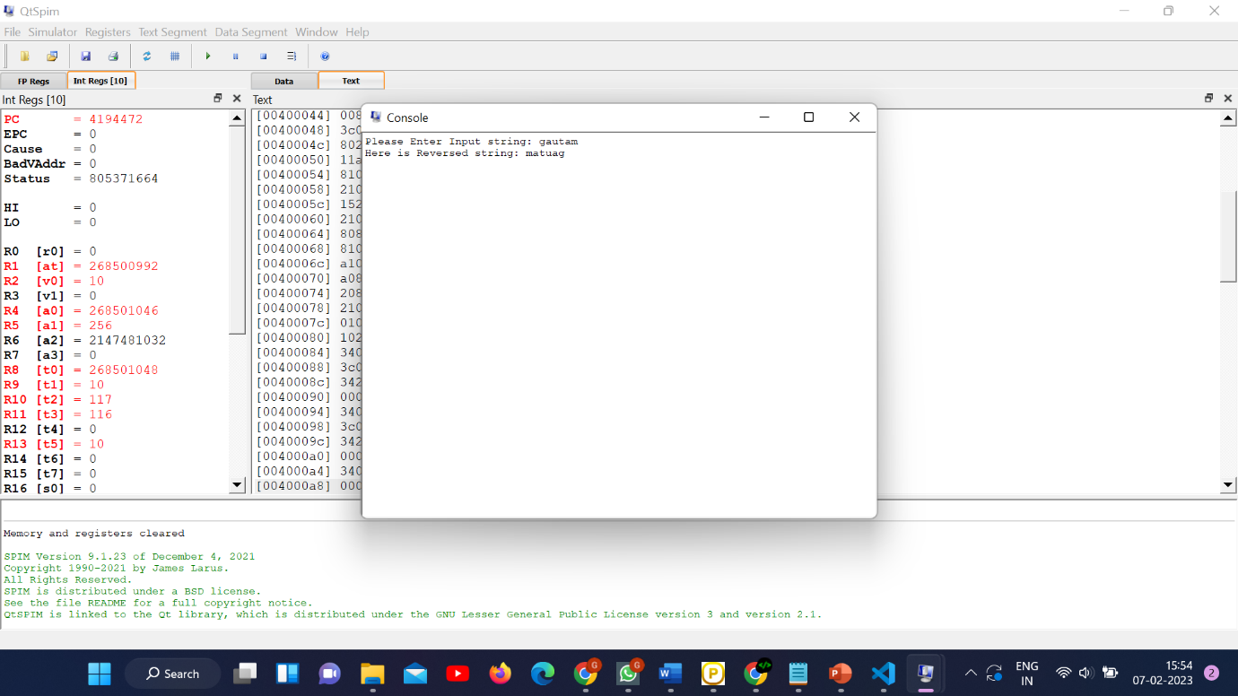

**In Hexa ­Decimal –**

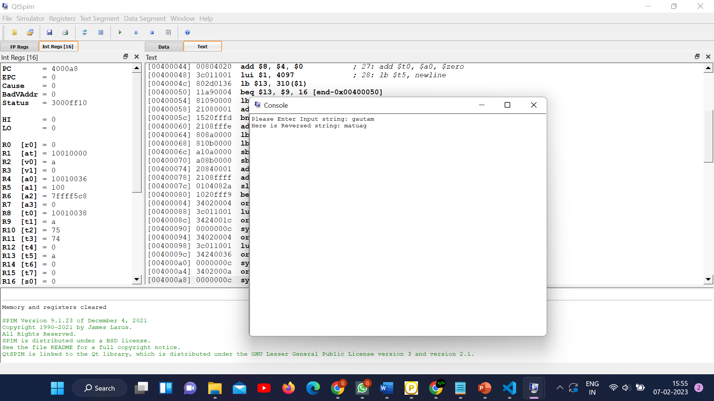

1. **Compute the dot product of two vectors each of length 5. Ask the user to enter the value of each element of the two vectors. Display the dot product. (Hint: The dot product of two vectors is sum of the product of the corresponding elements. For example, (1,2,3) dot (4,5,6) is 1*4+2*5+3*6 = 32)**

**In Hexa Decimal –**

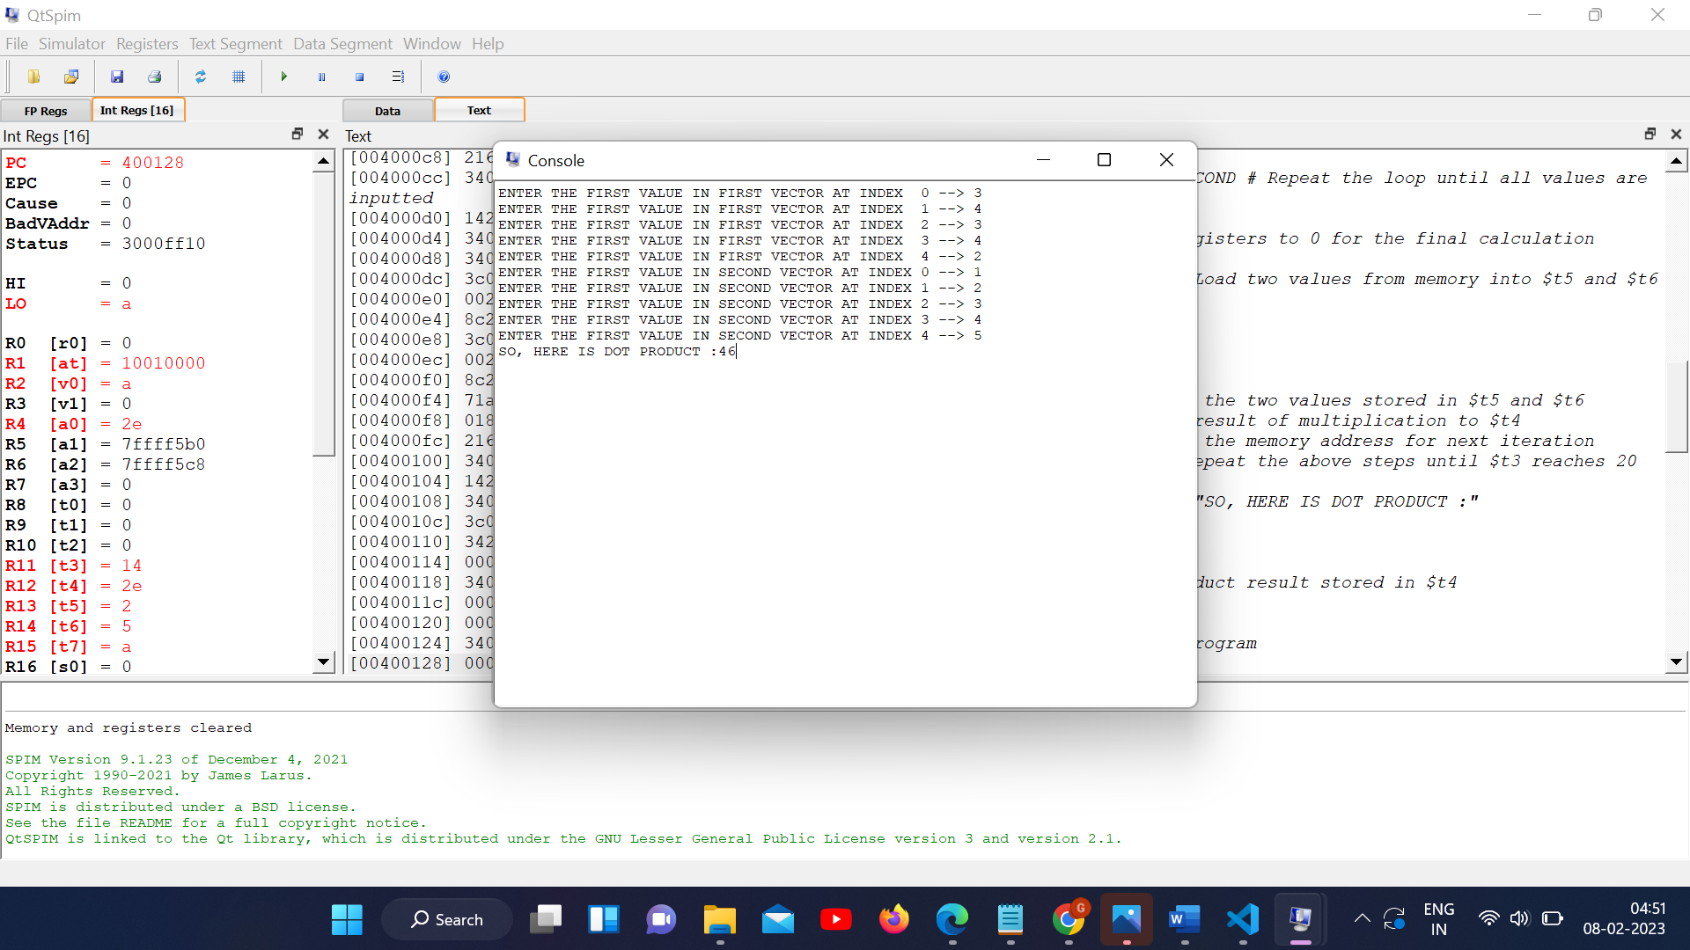

**In Decimal –**

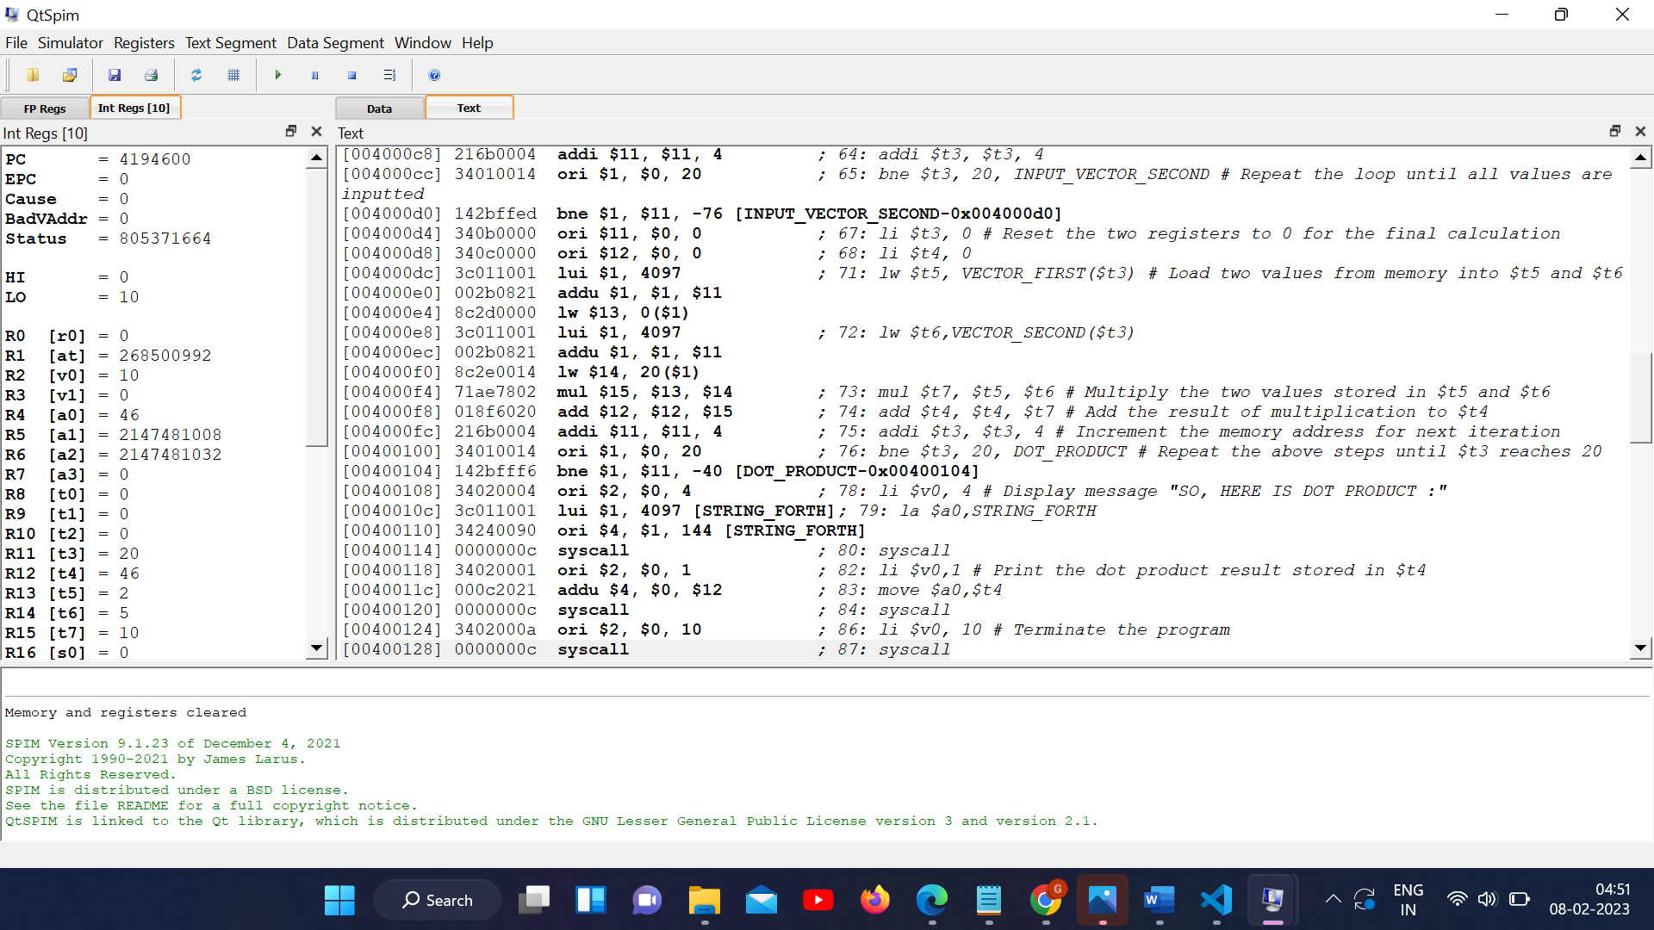

**Another Test Case –**

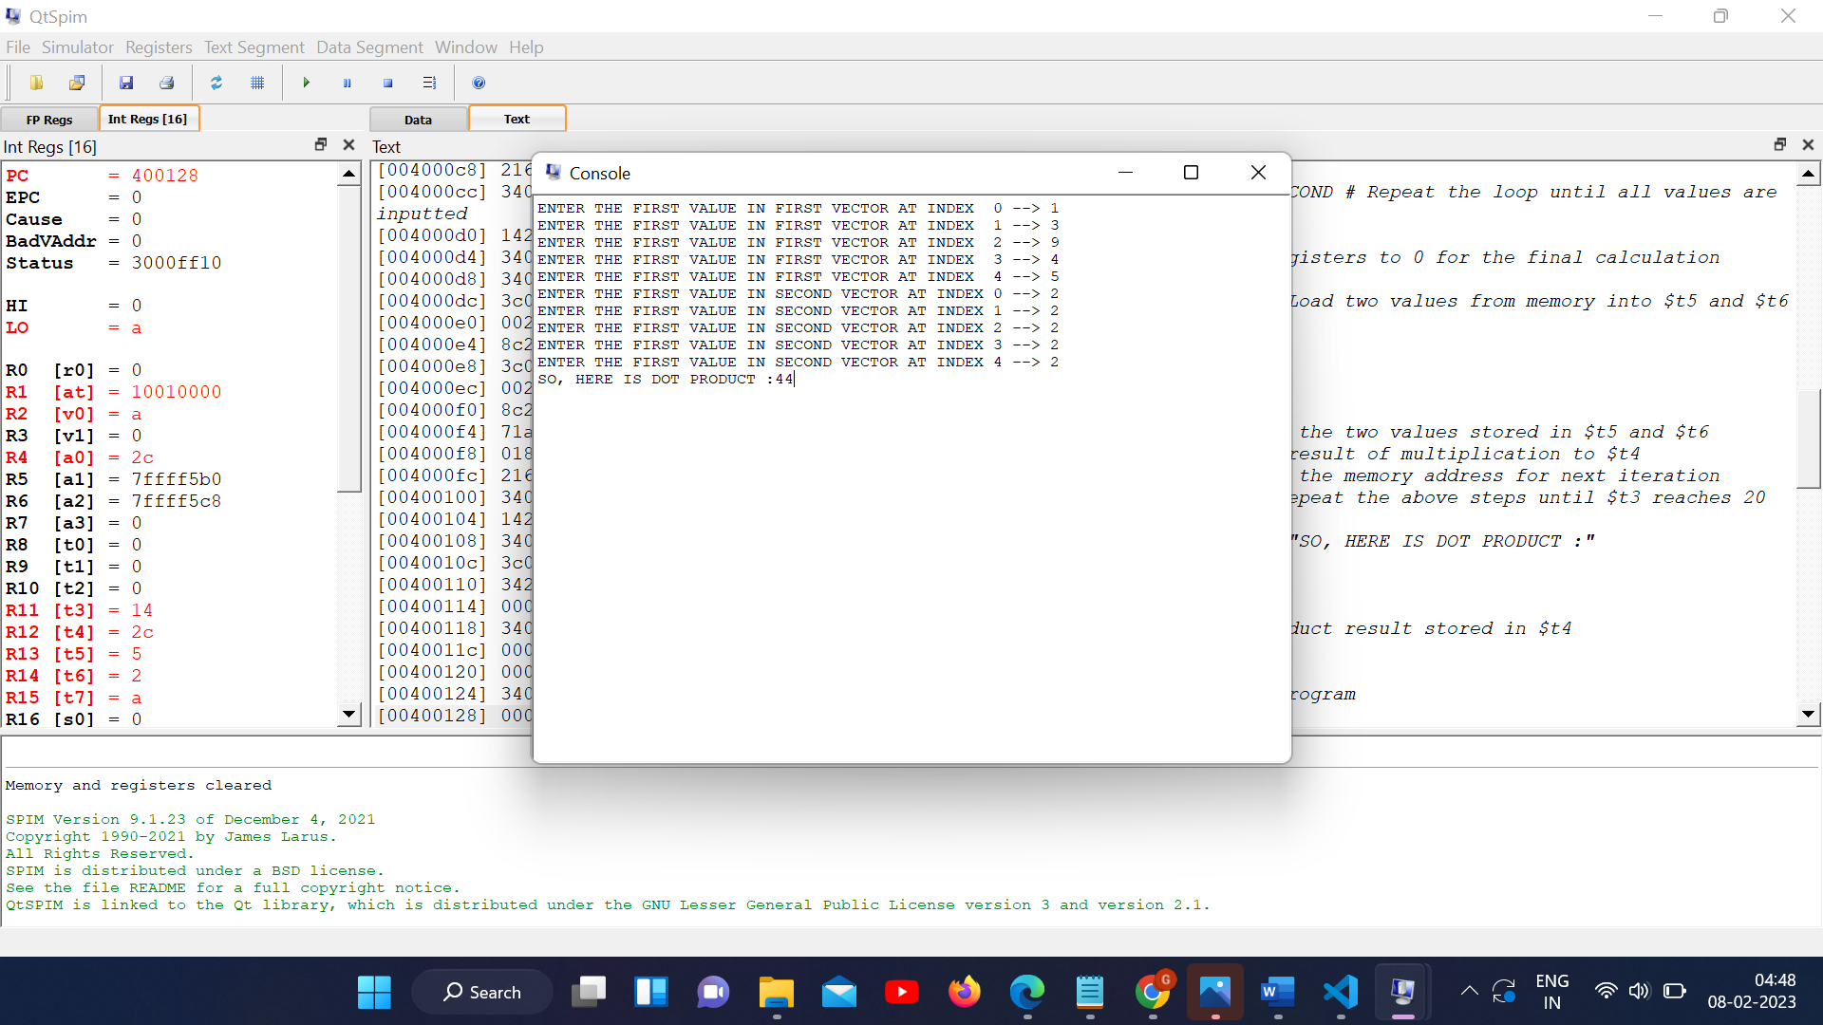

­­­­­

**3)** **Use lb $t1, 5($zero) to cause an exception when attempting to load a byte from address 5. What is the address of the lb instruction in your program? What is the value of the cause register, the exception code, the vaddr, and the epc when the exception occurs?**

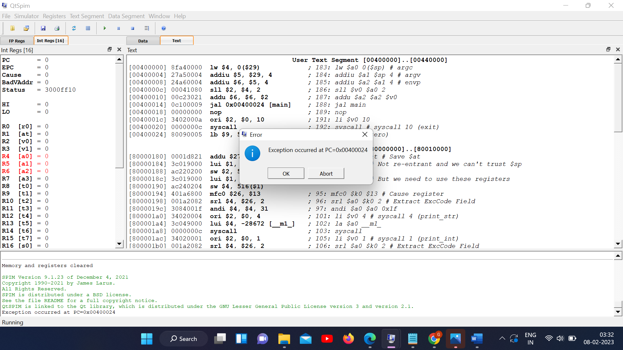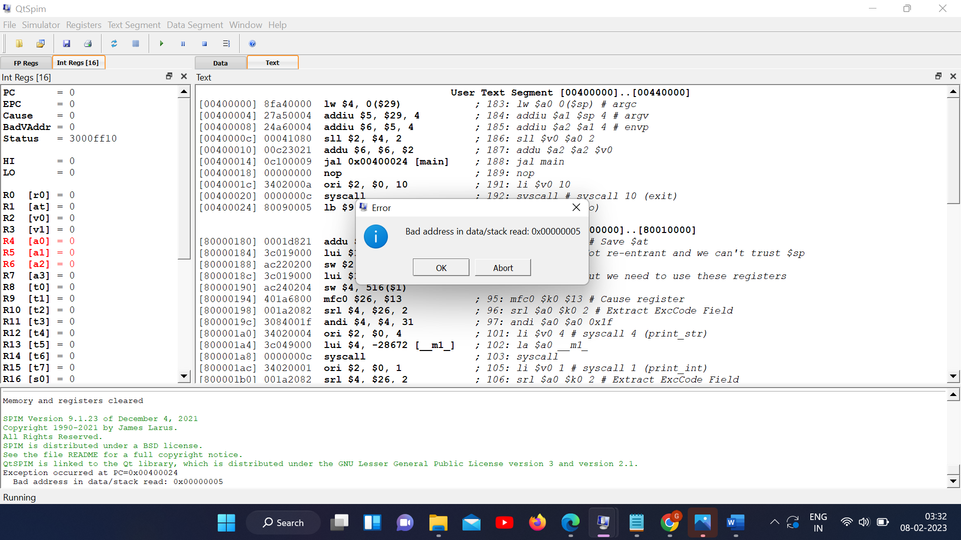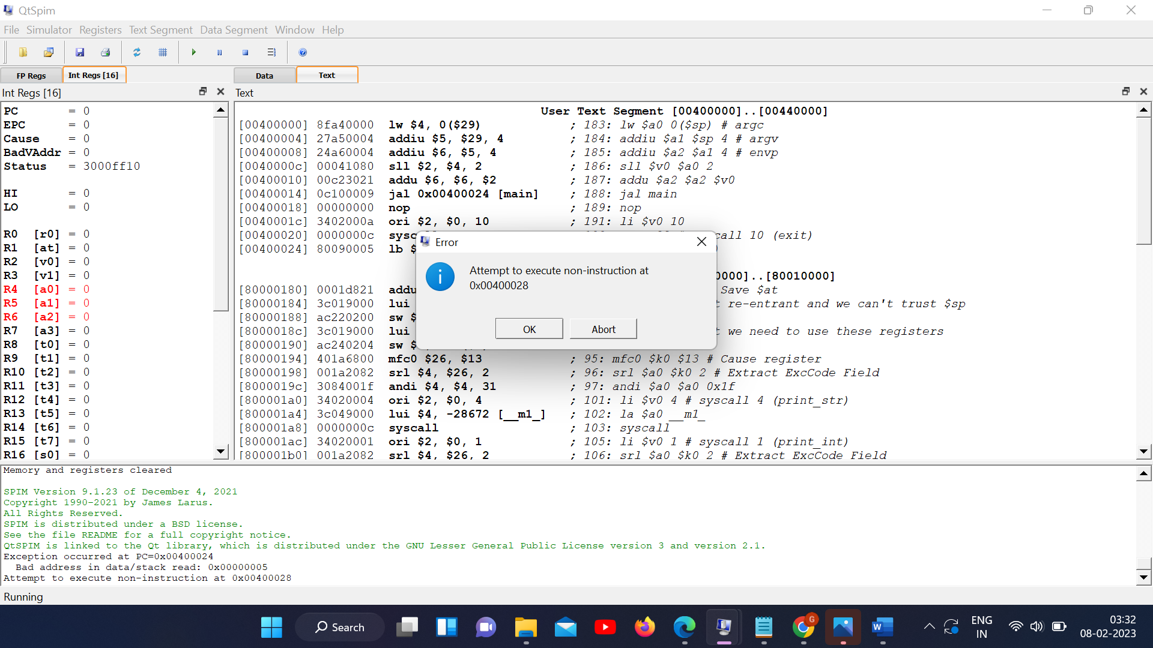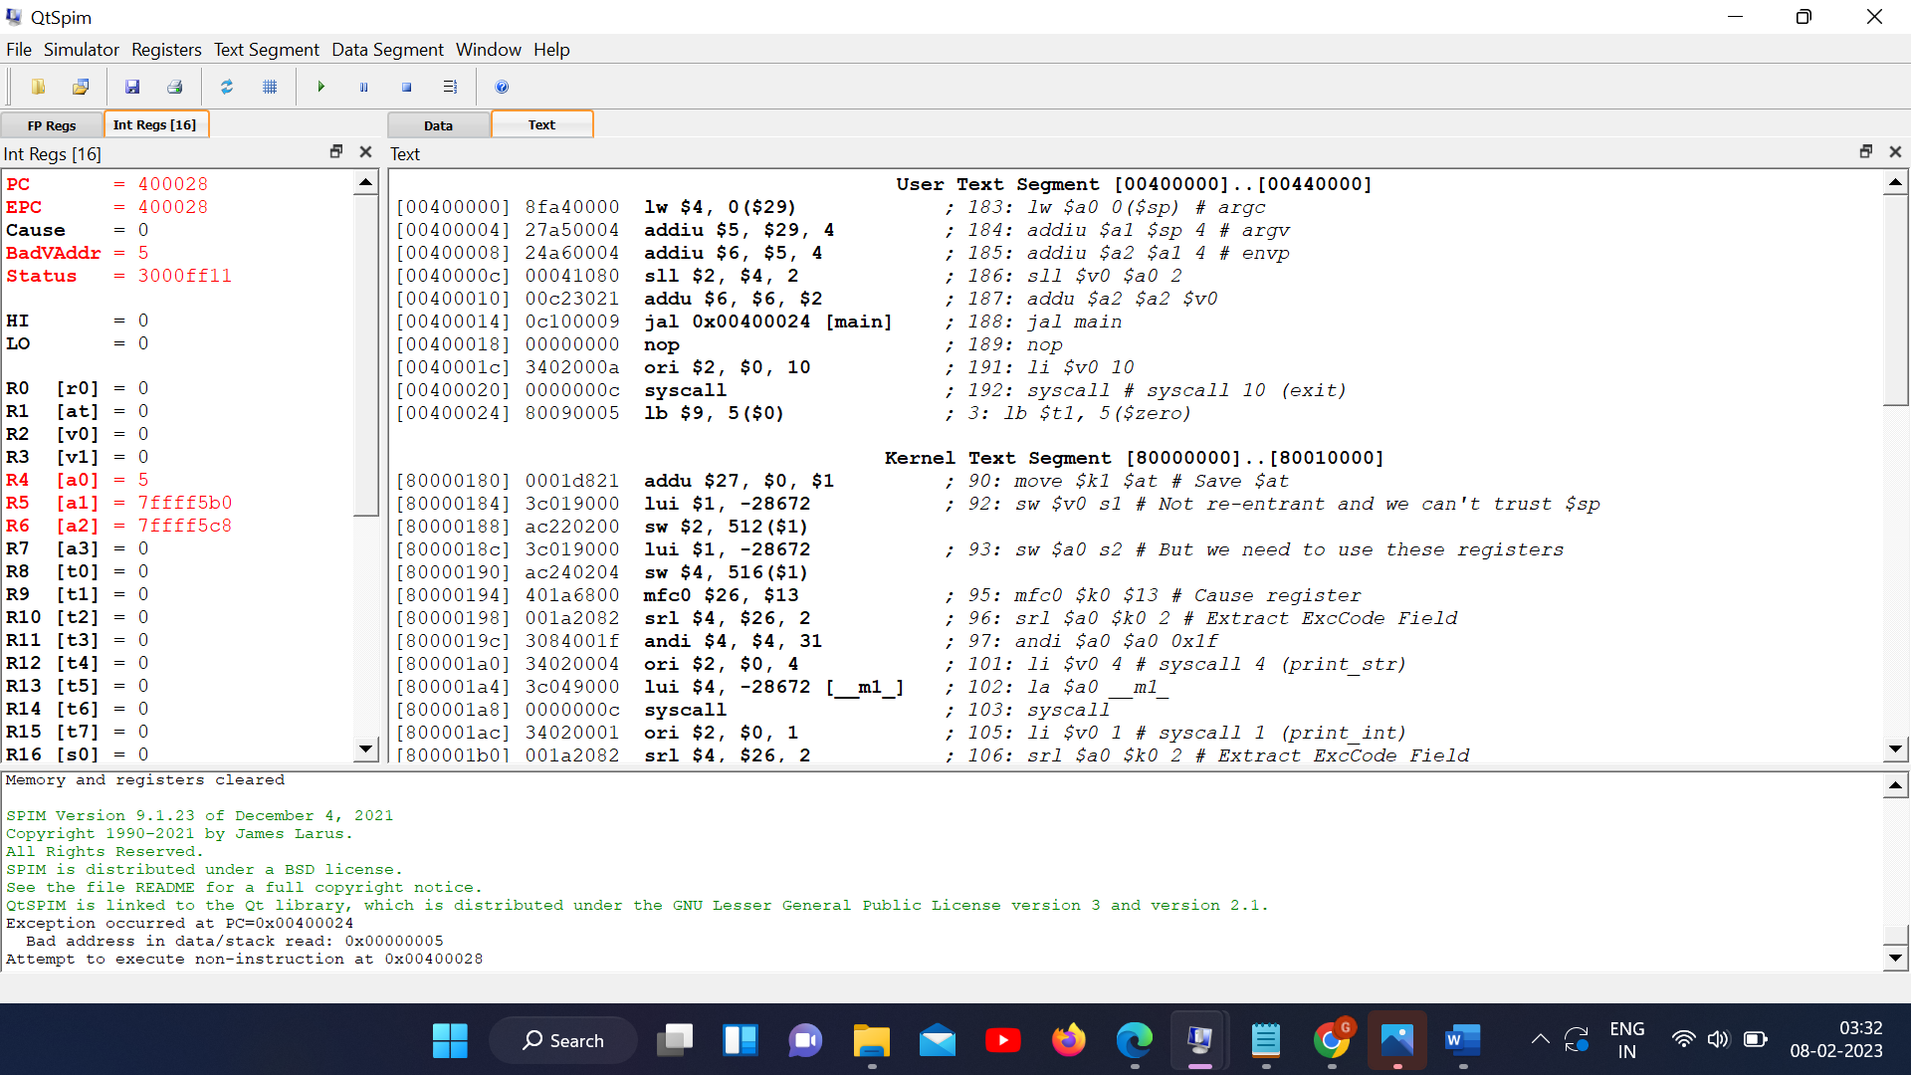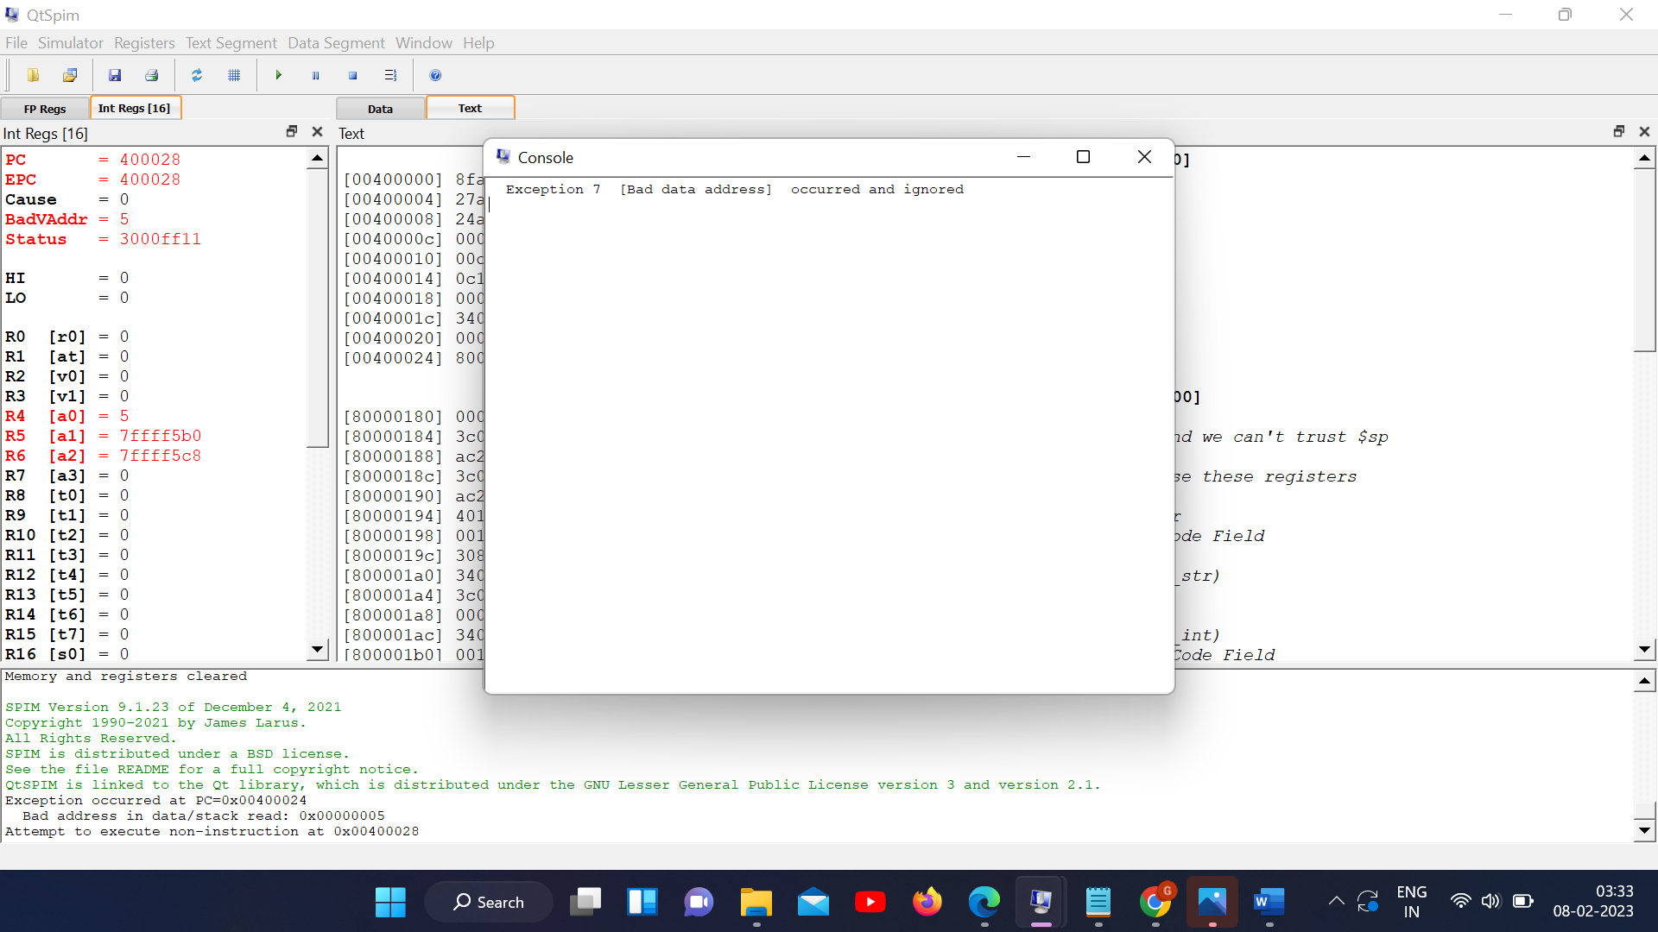

**The memory location is not allowed to be accessible. Permission Denied!**

**Thank You.**